**Prototype 3** **Name** Nihar Patel_____________________________________________ **15 points**

Paper copy as usual; also upload a copy of your homework outside your public_html directory to timestamp your work.

**1. PHP CODE (use Notepad++ so the code looks highlighted and has line numbers)**

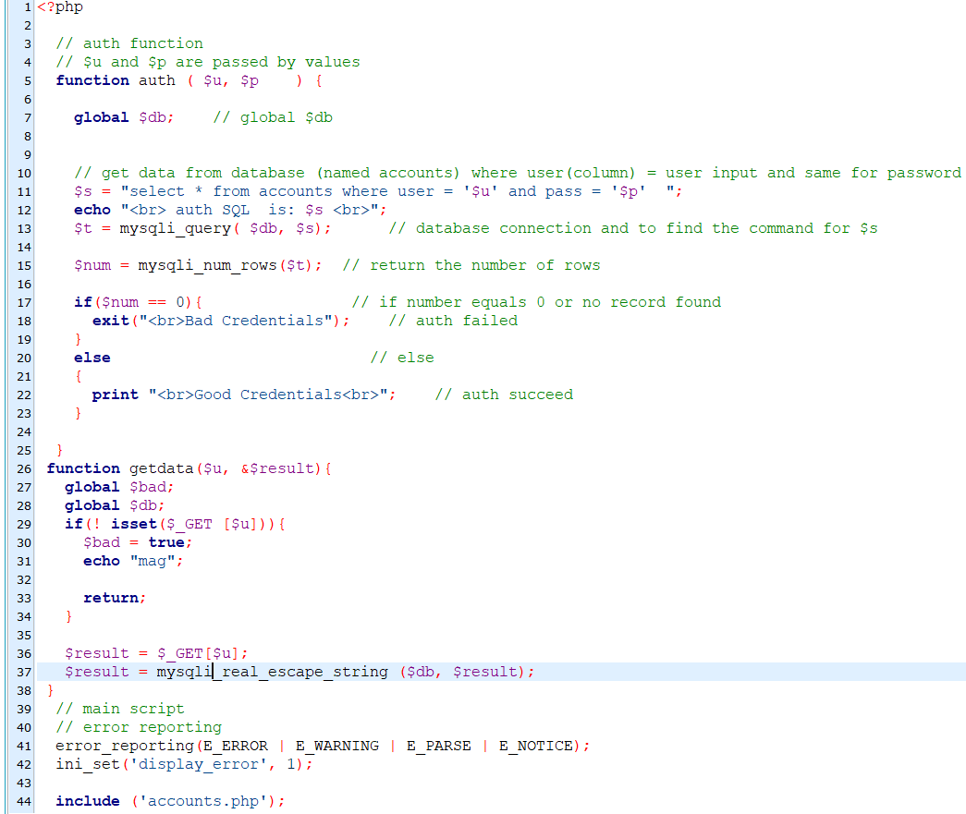

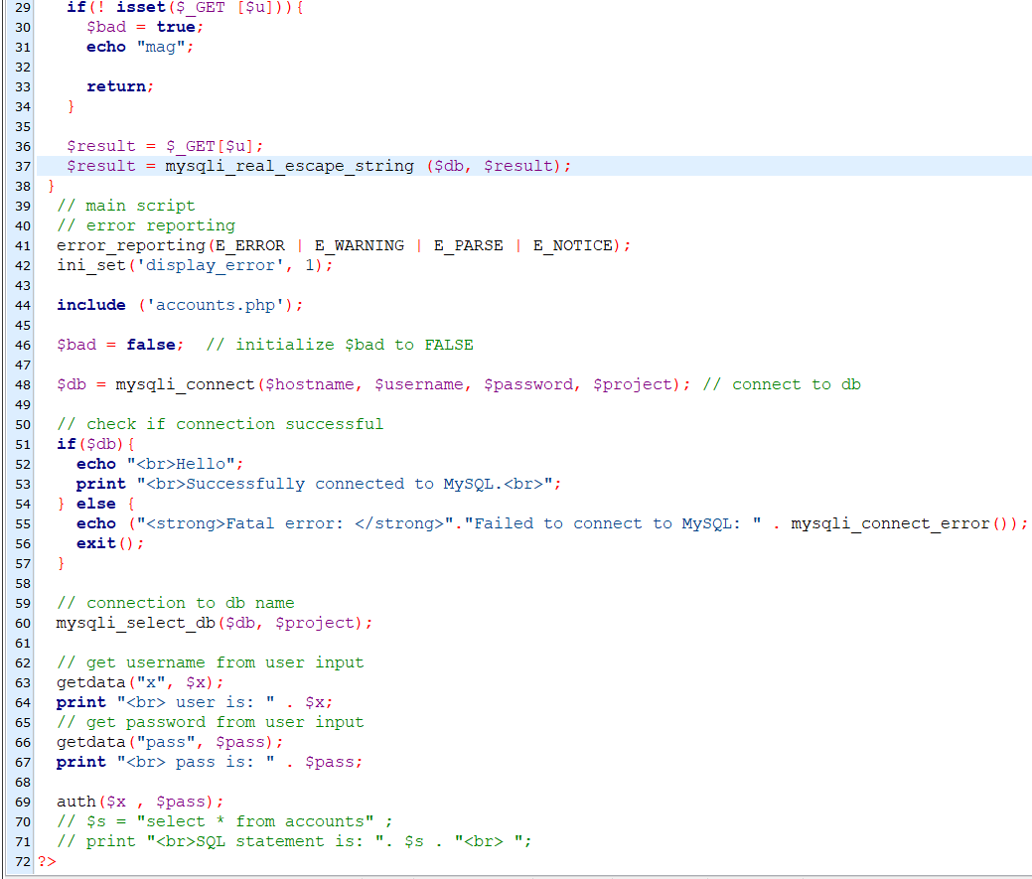

**2. HTML CODE (use Notepad++ so the code looks highlighted and has line numbers)**

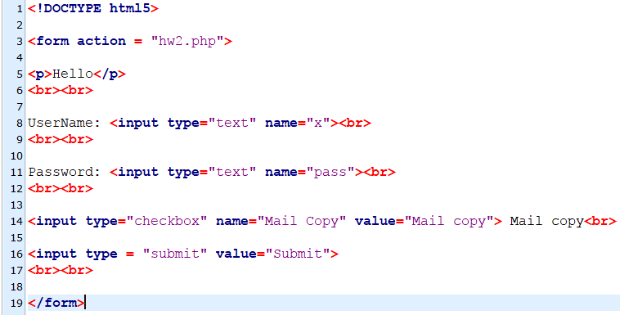

**3. Browser Output for CORRECT USER AND PASSWORD – and with mail box CHECKED**

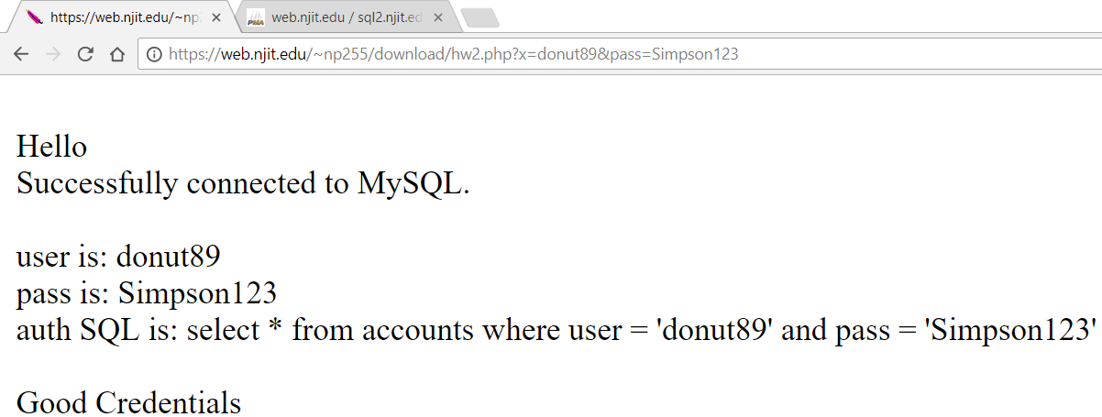

**4. Browser Output for INCORRECT USER OR PASSWORD (but not empty, no special characters)**

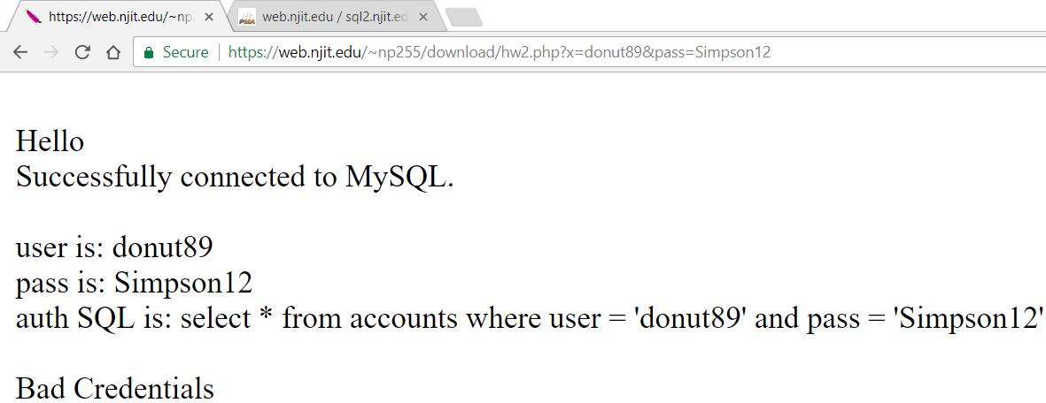

**5. Browser Output for an EMPTY INPUT USER OR PASSWORD**

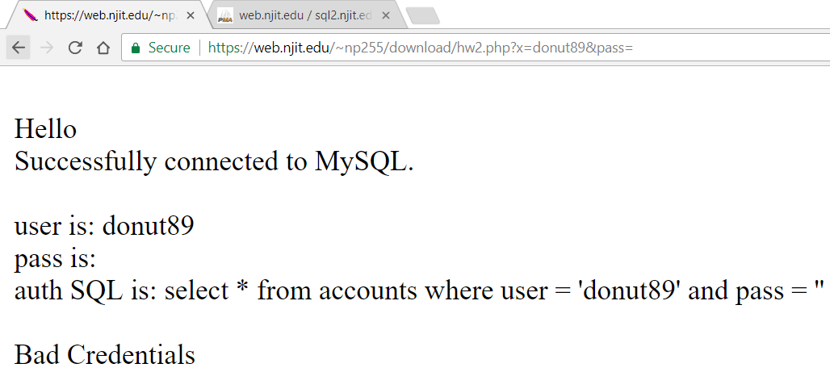

**6. Browser Output for SQL INJECTION IN PASSWORD FIELD**